FOR IMMEDIATE RELEASE
Contact: Joe Ferreira
Tel. (843) 237-5668
Email: joeferreira@msn.com

KNIGHTS OF COLUMBUS ASSEMBLY 3272 CHARITY GOLF TOURNAMENT
HELPS FUND BUILDING OF GEORGETOWN COUNTY VETERANS MEMORIAL WALL

July 15, 2014 (Georgetown – Pawleys Island, SC)
Thanks to the participation of 82 players in its 1st Annual 9 Hole Captain’s Choice Golf Tournament to benefit the Georgetown County Veterans Memorial Wall, Assembly 3272 of the Knights of Columbus raised $2500. Immediately following the tournament, Tom Bowen, Chair of the Knight’s Golf Committee, presented a $2,000 “check of expectation” to Frances “Jeep” Ford, Past Chairman of the Board of Directors of Georgetown Hospital System and to Bubba Ferdon, Member American Legion, Past Director of Georgetown Hospital System and Director of Georgetown County Veterans Memorial Inc. This anticipated donation was exceeded because of the special generosity of the players. The $2500 donation will help fund the construction of a memorial wall honoring the special men and women of the Georgetown County community who gave their lives in our nation’s military conflicts starting with the Revolutionary War.

Generous support from merchants in the Georgetown Community enabled every player to receive a door prize.
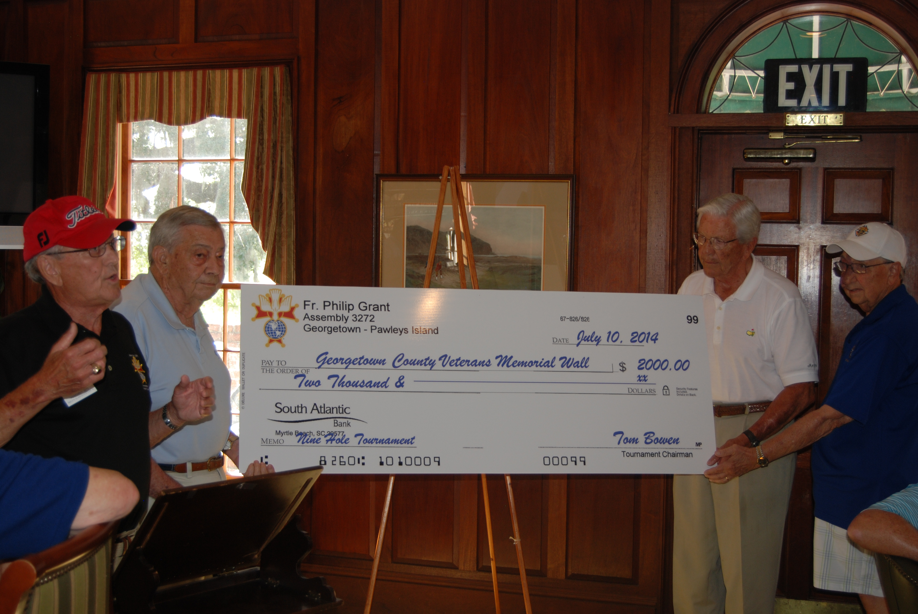
Tom Bowen (far left), Chair of the Knight’s Golf Committee, presents a $2,000 “check of expectation” to Frances “Jeep” Ford 2nd from left and to Bubba Ferdon. Golf Committee member (far right) Clem Thoennes looks on.

About The Georgetown County Veterans Memorial Wall
This granite memorial wall will sit between the current VFW Post 6444 building and the new American Legion Post 114 building on Church Street in Georgetown. The Memorial Wall will be approximately 3.5 feet high, 18 inches wide and about 80 feet long. The memorial will be topped with 10 flag poles that will fly the following flags: American, Flag, South Carolina Flag, MIA/POW Flag, American Legion Flag, VFW Flag, US Army Flag, US Navy Flag, US Marine Corps Flag, US Air Force Flag, and the US Coast Guard Flag.
###
With more than 1.8 million members, the Knights of Columbus is the world’s largest Catholic lay organization. It provides members and their families with volunteer opportunities in service to the Catholic Church, the community, families, and young people. During the past decade, the K of C has donated more than $1.4 billion to charity, and provided nearly 640 million hours of volunteer service in support of charitable initiatives.

